## FPT ACADEMY INTERNATIONAL FPT – APTECH COMPUTER EDUCATION



### Centre Name: ACE-HCMC-2-FPT.

**Address: 590 Cach Mang Thang 8, District 3, Ho Chi Minh City, Viet Nam.**

Hudson Furnishings

|  |  |  |
| --- | --- | --- |
| **Supervisor:** | Ms. Le Mong Thuy | |
| **Semester:** | 1 | |
| **Batch No:** | T1.2406.E1 | |
| **Group No:** | 5 | |
| **Order:** | **Name** | **Student ID** |
| 1. | Nguyen Pham Minh Dang | Student1575499 |
| 2. | Do Hoang Duc Minh | Student1571998 |
| 3. | Trinh Hieu Nghia | Student1580668 |

Date: October - 2024

### This is to certify that.

**Mr.** Nguyen Pham Minh Dang

**Mr.** Do Hoang Duc Minh

**Mr.** Trinh Hieu Nghia

### Have successfully designed & developed:

eProject: Hudson Furnishings

### Submitted by:

Ms. Le Mong Thuy

**Date of issue:** October 1st 2024

### Authorised Signature:

## Table of Contents

Table of Contents

FPT ACADEMY INTERNATIONAL FPT – APTECH COMPUTER EDUCATION 1

Centre Name: ACE-HCMC-2-FPT. 1

This is to certify that. 2

Have successfully designed & developed: 2

Submitted by: 2

Authorised Signature: 2

Table of Contents 2

ACKNOWLEDGEMENT 3

SYNOPSIS 3

ANALYSIS 3

1. Purpose of the Website. 3

2. Design and Interface. 3

3. Technical Requirements 4

CUSTOMER'S REQUIREMENTS SPECIFICATIONS 4

Client: APT India Co. 4

1. Business/Project Objective 4

Hardware/ Software Requirements 5

1.1 Hardware 5

1.2 Software 5

SCOPE OF THE WORK (IN BRIEF) 6

1. Home: 6

2. About Furniture Website 6

3. Gallery 6

4. Feedback and rating 6

5. Contact: 6

6. FAQ: 6

ARCHITECTURE AND DESIGN OF THE SYSTEM 7

DIAGRAM OF THE WEBSITE 8

TASK SHEET REVIEW 1 9

MOCK OF THE WEBSITE 11

1. Home 11

2. All Furniture 12

3 Contact Us 13

WEBSITE DESCRIPTION 15

Homepage and overview design: 15

Furniture Info: 17

Contact Us: 19

FAQ: 20

Gallery: 21

About us: 22

TASK 3 REVIEW 23

## ACKNOWLEDGEMENT

On behalf of my team members. I want to thank everyone who has supported me and my teammate on this eProject report. For a very lovely mention, I want to thank a lot to our teacher, she helped us a lot on our journey to success since we started studying at FPT Aptech. With this eProject, she guided us very meticulously, enthusiastically and strictly. With her guidance, we were able to complete this project successfully. Besides, I also want to thank all the team members, each of whom worked hard to complete the eProject in earnest during the month of working together. Finally, our group would like to say thank you to my classmates and family for sharing and creating for the group the best environment to focus on the project.

## SYNOPSIS

Furniture includes various types of household appliances and decorations with an emphasis on interior designs. Despite the similar uses with other furniture shops, we are the only Palliser custom order studio, which offers more than 300 different fabrics or leathers to meet all your furniture needs. Shopping with us is designed to be simple and stress-free, with organized showrooms that allow customers to easily find and select pieces for their homes. Our furniture reflects careful craftsmanship and attention to detail, ensuring high-quality designs that help transform any house into a home.

## ANALYSIS

### Purpose of the Website.

This website mainly works as an online store that sells furniture for bedrooms, living rooms, dining rooms, office rooms, etc like: mattresses, sofa stores, and other general furniture. The website will provide you with the easiest way to search for any furniture follow your style and decorate. It will also help you to find your favourite furniture from any branch or price.

### Design and Interface.

* + The website features a user-friendly environment and navigation. Key menus are positioned at the top for easy access to information.
  + The interface and colour scheme are harmoniously combined to create a visually appealing and engaging experience for users.

### Technical Requirements

* + The website must perform well across all major browsers including Chrome, IE, Firefox, etc., ensuring accessibility from various devices and platforms.
  + It utilizes a single-page application (SPA) approach to deliver a seamless and fast web browsing experience.
  + Features are designed to meet technical requirements, facilitating quick and accurate loading and display of information.

The mountaineering website aims to be a valuable and attractive source of information for enthusiasts, providing everything you need about products and services.

## CUSTOMER'S REQUIREMENTS SPECIFICATIONS

### Client: APT India Co.

### Business/Project Objective

The portal will be designed as **a** Single-Page-Application and responsive Website with

a set of pages and menus that represent **the** choice of activities to be performed. The

pages, menus, and other visual elements must be designed in a visually appealing

manner with attractive fonts, **colours**, and animations.

All of these should also be laid out in a responsive manner

The Web site is to be created based on the following requirements.

1) The Top of the Page should be presented with a suitable logo and various

images of furniture.

2) The site must contain various sections like BEDROOM, LIVING ROOM, DINING

ROOM, HOME OFFICE, OUTDOOR etc. with various products listed on it.

3) A Menu should be provided with the section names and should be linked to

the sections.

4) Filters should be provided for Category, Type, Price Range, Material, Brands

etc.

5) Clicking on any product should open a pop-up window with images, description

and the price of the product.

6) A gallery should be added for viewing different images.

7) Feedback and Rating must be allowed to **be entered** by the viewer

8) Site map, Gallery, **About Us**, FAQ link, **and** Contact **Us** link must be added.

9) About Us and Contact Us: This menu option should display **the email ID**, address,

and contact number.

**10) A section for various offers in the store should be provided with a listing of offers**

**with details.**

**11) Color combinations must be uniform throughout the project.**

12) Navigation must be smooth.

Over and above this, the portal should implement the following functionalities:

Display a continuous scrolling ticker at the bottom of the page with the current date,

time, and location (hint: Use geolocation features of HTML5).

Display a visitor count at the top right corner of the page beside a logo image.

The menu options should change colour on hover and also after clicking.

Fade-in and fade-out options can be used for the menus.

### Hardware/ Software Requirements

### Hardware

* + - Intel Core i3/i5 Processor or higher
    - 8 GB RAM or above
    - Color SVGA
    - 500 GB Hard Disk space
    - Mouse
    - Keyboard

### Software

Technologies to be used:

* + - Frontend: HTML5, CSS, Bootstrap, JavaScript, jQuery, React/AngularJS, Figma, XML
    - Data Store: JSON files or TXT files Other Requirements:
    - Operating Portal: Windows
    - Browsers: Edge, Chrome, Mozilla Firefox, Safari

# SCOPE OF THE WORK (IN BRIEF)

### Home:

* + Logo and furniture images displayed at the top of the page.
  + Overview section displaying hot offers or featured furniture products.
  + Menu options should be present in the header for easy navigation.

### About Furniture Website

* + BEDROOM
  + **LIVING ROOM**
  + DINING ROOM
  + HOME OFFICE
  + OUTDOOR
  + Hot Offer

Each section should feature relevant products, allowing users to browse different furniture categories. And have a filter for easily finding own style furniture,

### Gallery

* + A gallery for showcasing various images related to the furniture collection should be included.

### Feedback and rating

Viewers should be able to leave feedback and provide ratings for the products.

### Contact:

Contact information for users to contact or send feedback.

### FAQ:

A section addressing common questions related to the furniture store. And will be heading forward to the Contact page.

## ARCHITECTURE AND DESIGN OF THE SYSTEM

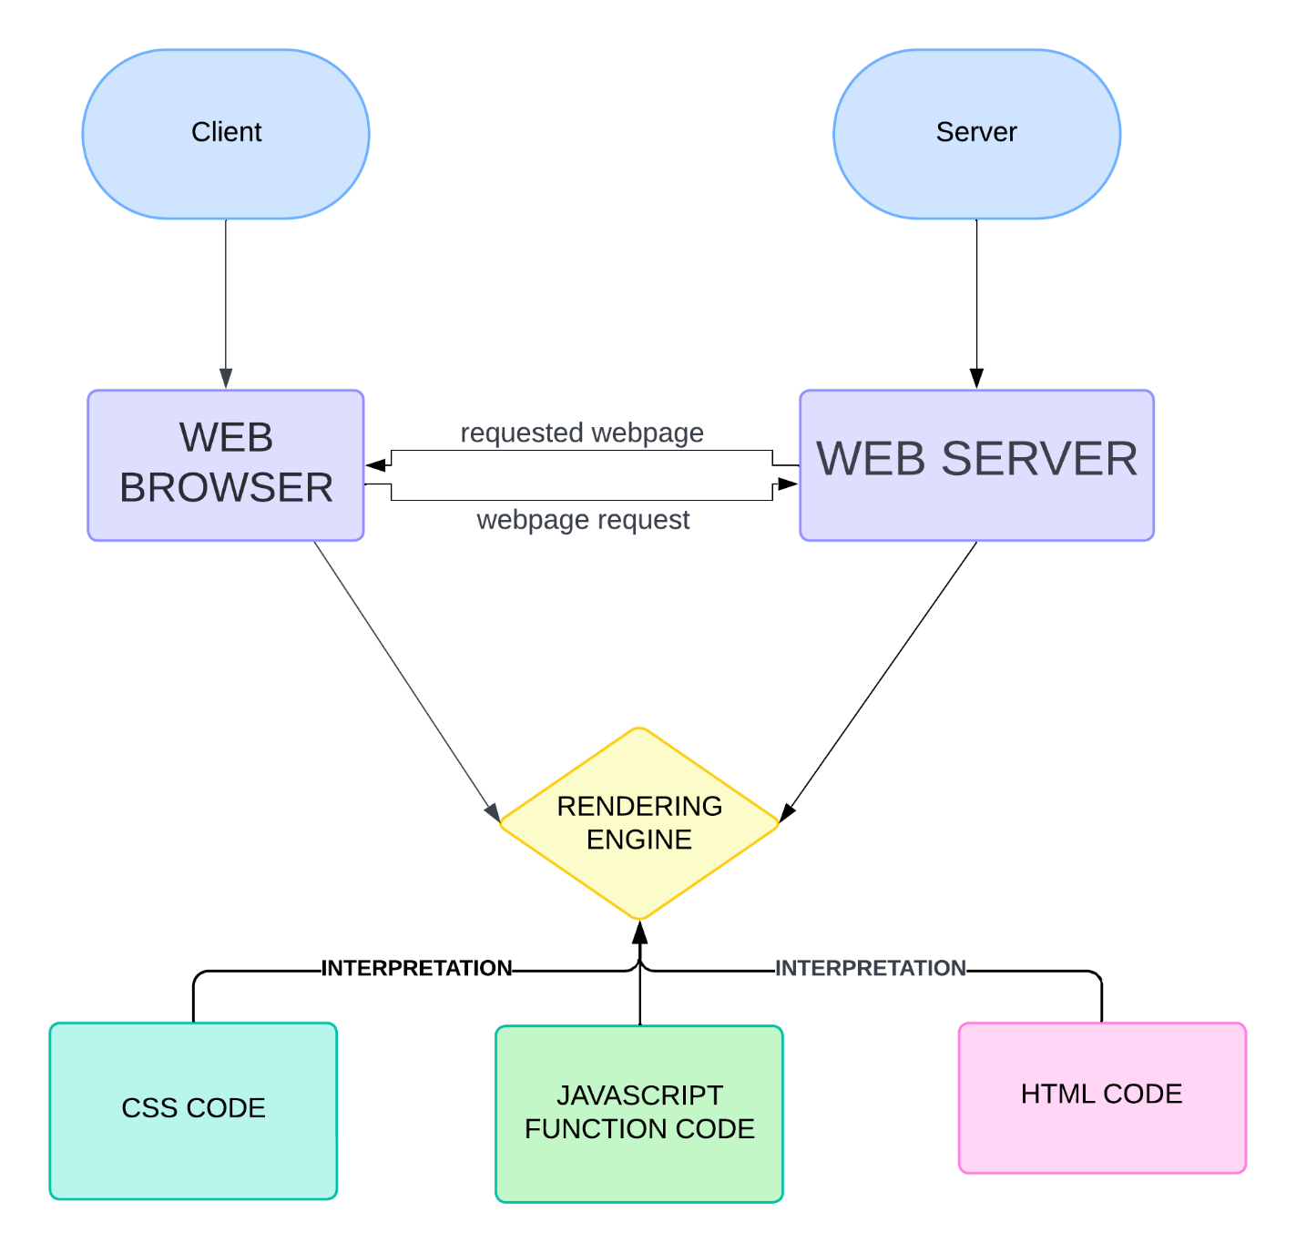

## DIAGRAM OF THE WEBSITE

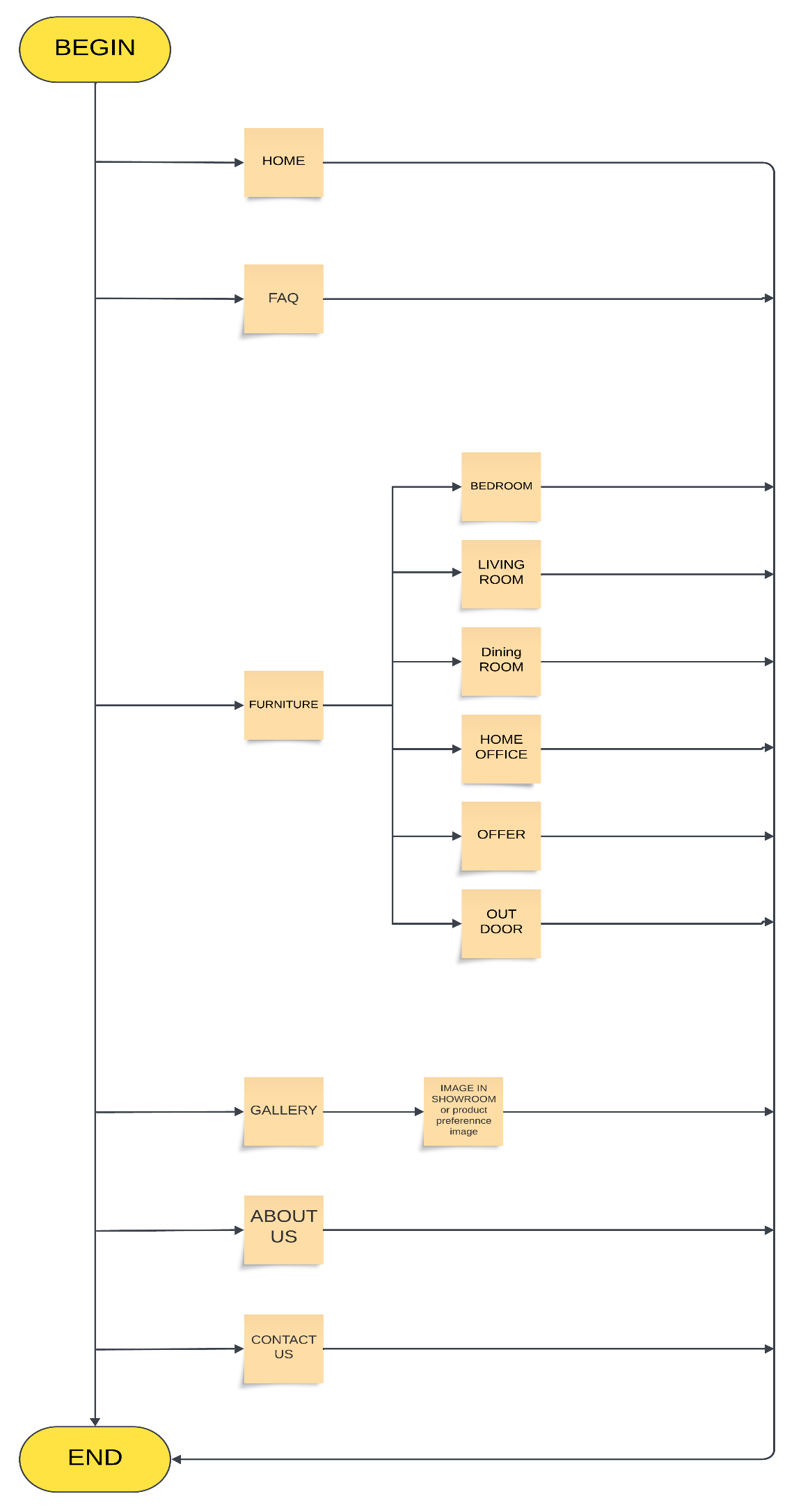

## TASK SHEET REVIEW 1

|  |  |  |  |  |  |  |  |
| --- | --- | --- | --- | --- | --- | --- | --- |
| **Project Ref. No.: eP/Advertisement Portal Management System/01** | | **Project Title:** | **Activity Plan Prepared By:** | **Date of Preparation of Activity Plan:** | | | |
| **Sr.No** | **Task** | **Actual Start Date** | **Actual Days** | **Team Mate Names** | **Status** |
| 1 | Synopsis | Hudson Furnishings | Dang | 10/02/24 | 1 | Minh | Completed |
| 2 | Analysis | 10/02/24 | 1 | Dang | Completed |
| 3 | The scope of the work | 10/02/24 | 1 | Nghia | Completed |
| 4 | Architecture and design of the system | 10/02/24 | 1 | Minh | Completed |
| 5 | Diagram of the website | 10/02/24 | 1 | Nghia | Completed |
| 6 | Task Sheet Review | 10/02/24 | 1 | Dang | Completed |

|  |  |
| --- | --- |
| **Date:** | |
| Signature of Instructor:  **Le Mong Thuy** | Signature of Team Leader:  **Nguyen Pham Minh Dang** |



**SITE MAP**

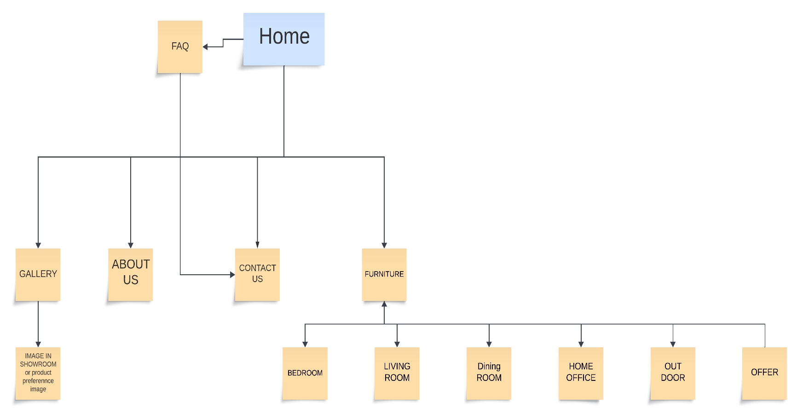

## MOCK OF THE WEBSITE

### Home

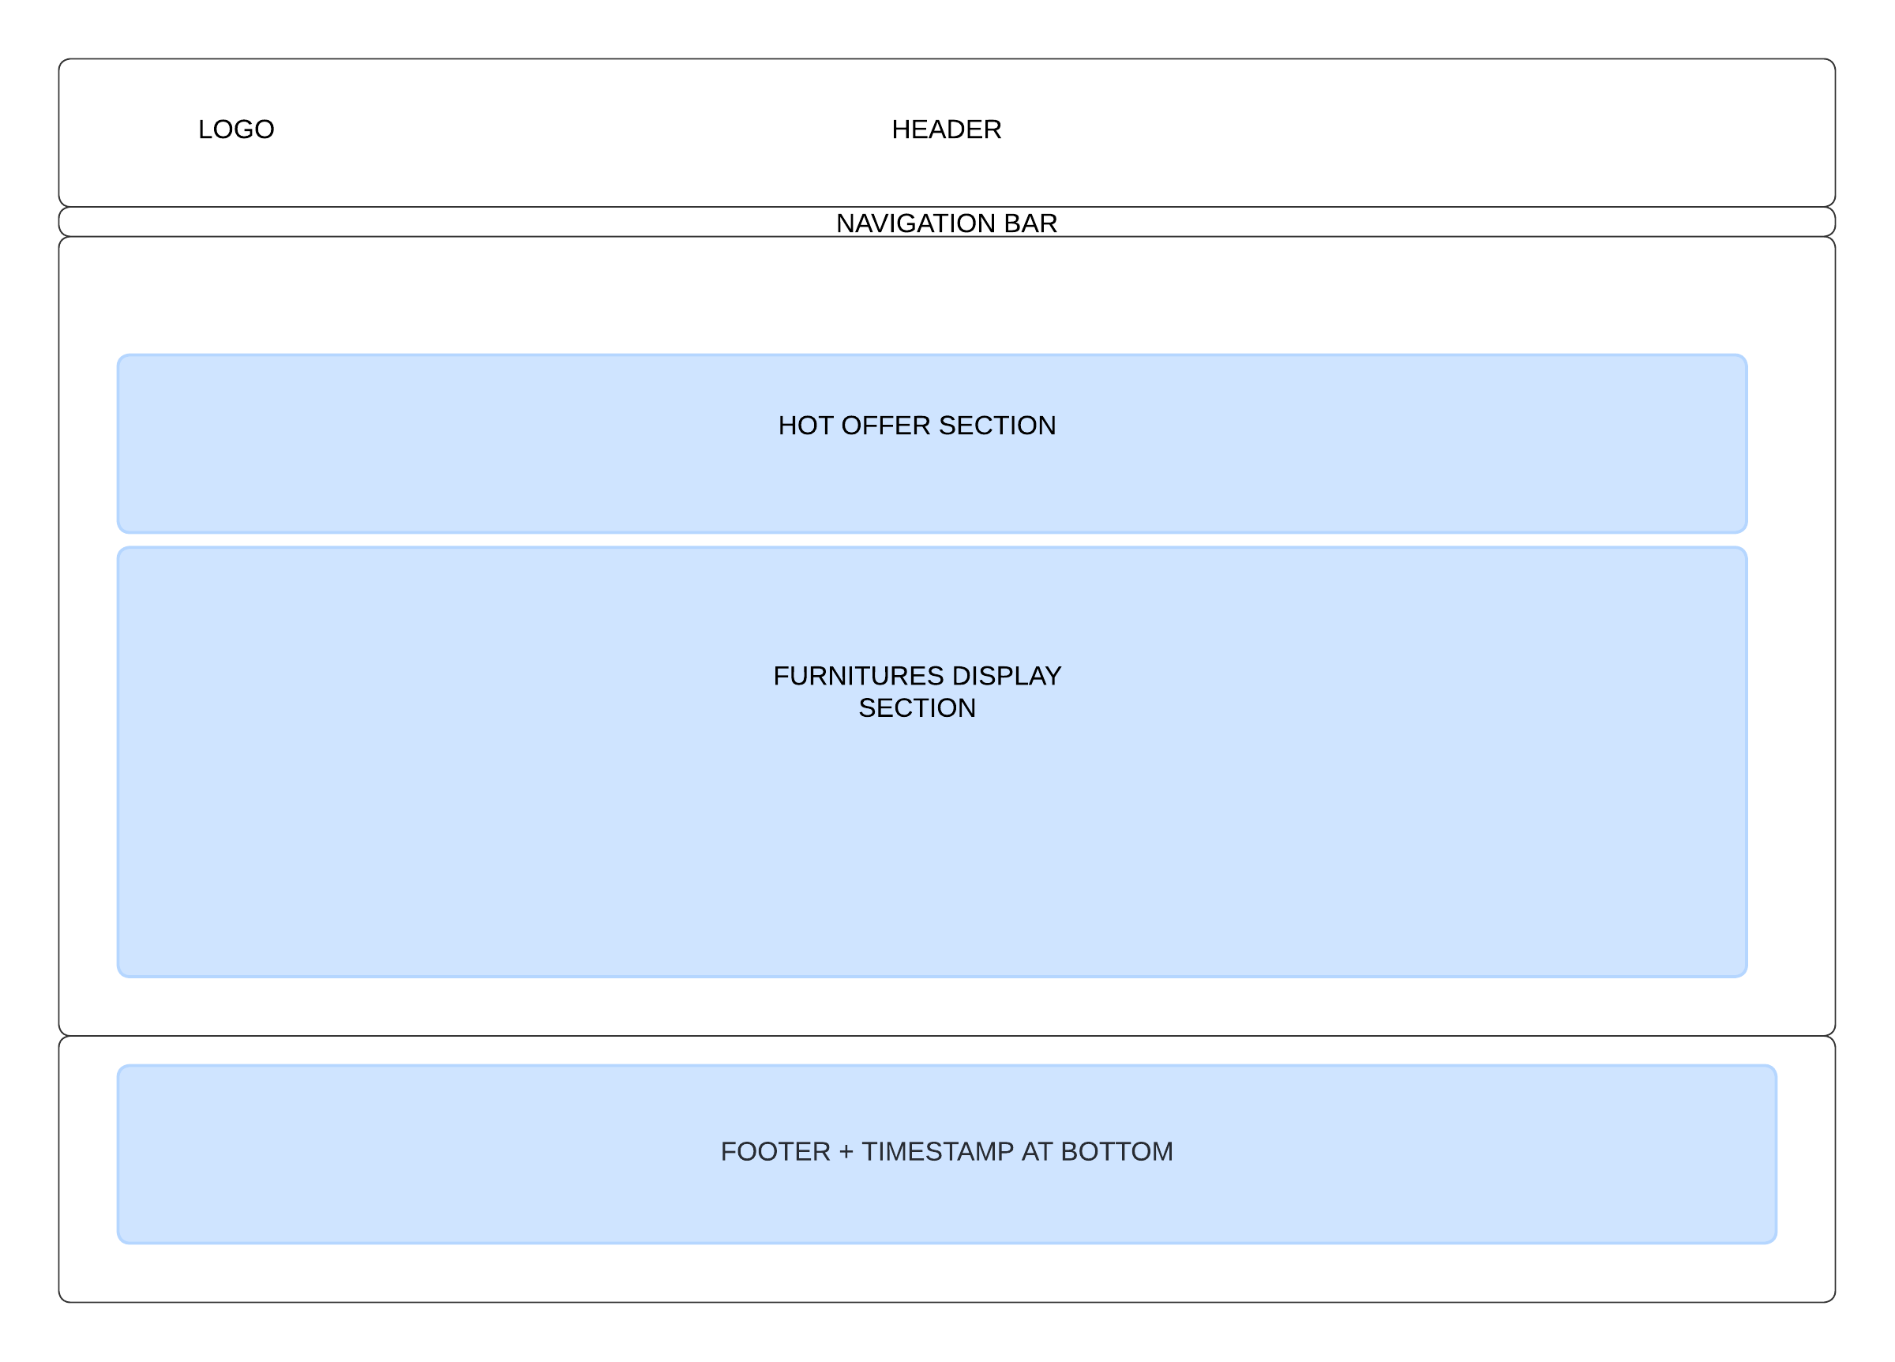

### All Furniture

* 1. **Bedroom**
  2. **Living Room**
  3. **Dining Room**
  4. **Home Office**
  5. **Out Door**
  6. **Hot offer**

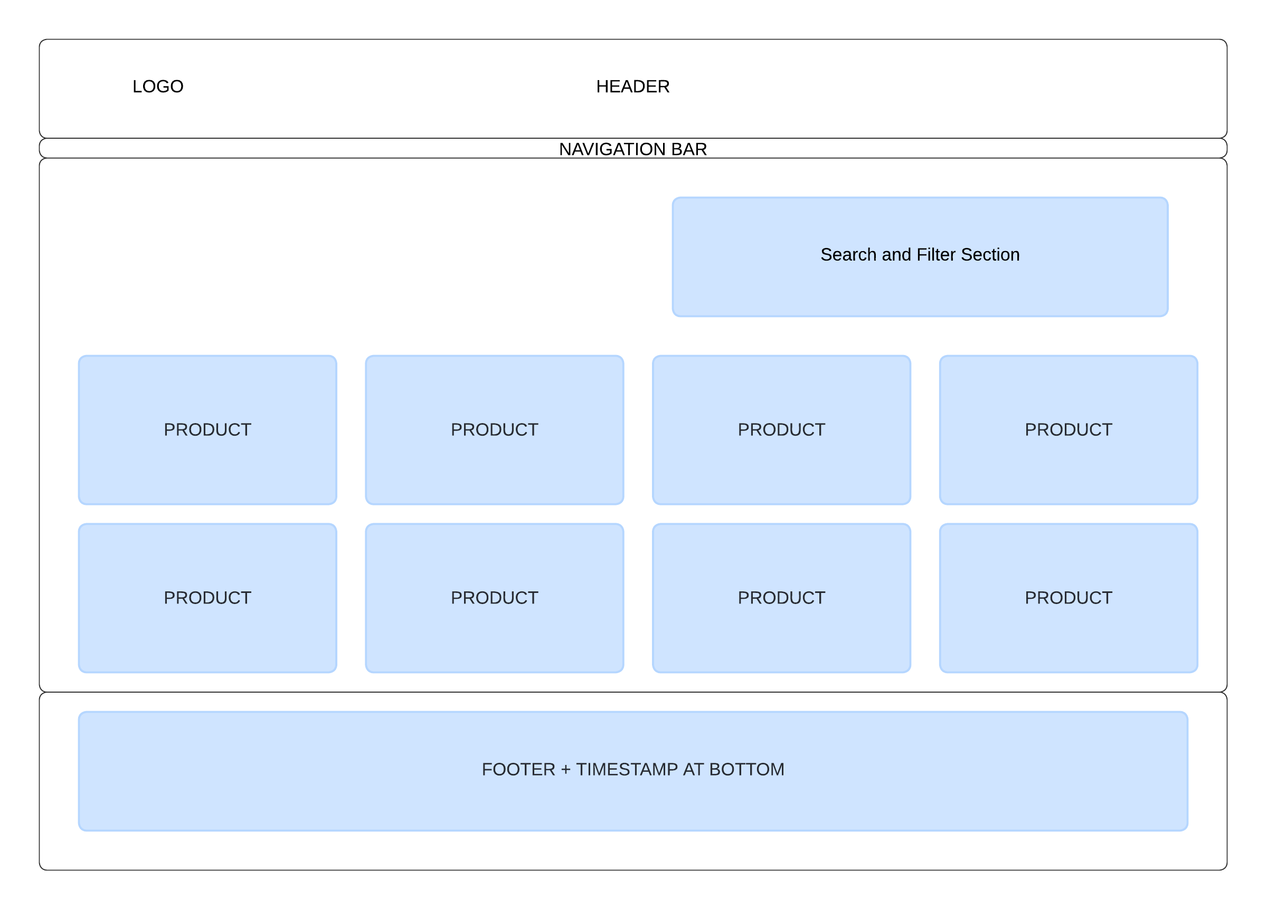

### Contact Us

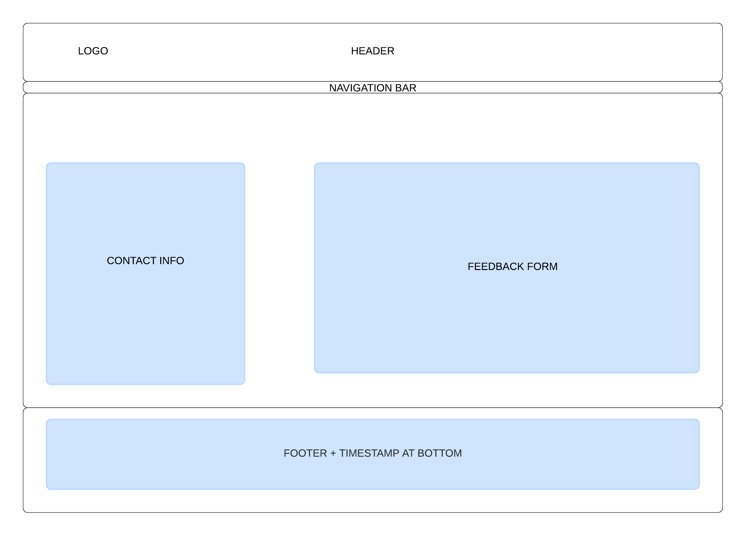



**TASK SHEET REVIEW 2**

|  |  |  |  |  |  |  |  |
| --- | --- | --- | --- | --- | --- | --- | --- |
| **Project Ref. No.: eP/Advertisement Portal Management System/01** | | **Project Title:** | **Activity Plan Prepared By:** | **Date of Preparation of Activity Plan:** | | | |
| **Sr.No.** | **Task** | **Actual Start Date** | **Actual Days** | **Team Mate Names** | **Status** |
| 1 | Site map | Hudson Furnishing | Dang | 24/6/24 | 2 | Dang | Completed |
| 2 | Mock of website | 24/6/24 | 2 | Dang | Completed |
| 3 | Task sheet Review | 24/6/24 | 2 | Dang | Completed |

|  |  |
| --- | --- |
| **Date: 04/10/2024** | |
| Signature of Instructor:  **Ms. Le Mong Thuy** | Signature of Team Leader:  **Nguyen Pham Minh Dang** |

## WEBSITE DESCRIPTION

UPDATE: The Hot Offer Section seems to be useless for real-life use so I decided to put it out. The offer will be displayed above the store section and each section will display the offer of that furniture.

### Homepage and overview design:

If you hover on the card in the main section, it will become bigger with image opacity and size transition effect.

In the bottom right we also provided a vistors and to-top button for mobile/desktop users.

At the end of the page, in the footer, there will be a site map, contact us info and relatives link which can be easily modified. We also provided a video about furniture at the end provide by IKEA.

-There is a scrolling ticker that will display time + customer geo-location.

THIS PAGE WAS LEFT BLANK INTENTIONALLY.

### Furniture Info:

After the customer selects which type of furniture they wish, our pages will take them to a page that will display all kinds of furniture, we also provide a search bar which can search for product names (we have set it to only search if match with the starts letter). If there was an offer, the original price will have a line through and be replaced with an after-sales price below.

There will be 2 filters:

+Sort by Brand: You can sort by brand (Ashley, Ikea, Roche Bobois)  
+General Filters: These can be sorted from A, Z-A, Price High to Low, Low to High or no filter

*We can use both filters at the same time.

When a client clicks “Detail” on any product, there will be a pop-up with that product information:

The product image will change every 5 seconds so that the client can see more about the product and how it can be placed, in the pop-up will provide all product information like Name, Description, Price, Sales, and Rating.

If clients wish to leave a rating then they can click on the red text ‘Rating this Product’ which will pop up a rating UI.

They can leave the feedback with a star from 1-5.

THIS PAGE WAS LEFT BLANK INTENTIONALLY.

### Contact Us:

Come to the contact information page:

There will be a form that allows customers to fill out their feedback with their name, email address and feedback. On the left is also contact information and the hotline of the store. The form will make sure that the Name must start with a letter, not a space + no number is allowed in that box.  
  
An email box will make sure that a correct email is entered by checking if there are at least 3 characters in front of @ and at least 3 characters behind the @. A dot must be provided after that and at least 2 characters for addresses like .com

THIS PAGE WAS LEFT BLANK INTENTIONALLY.

### FAQ:

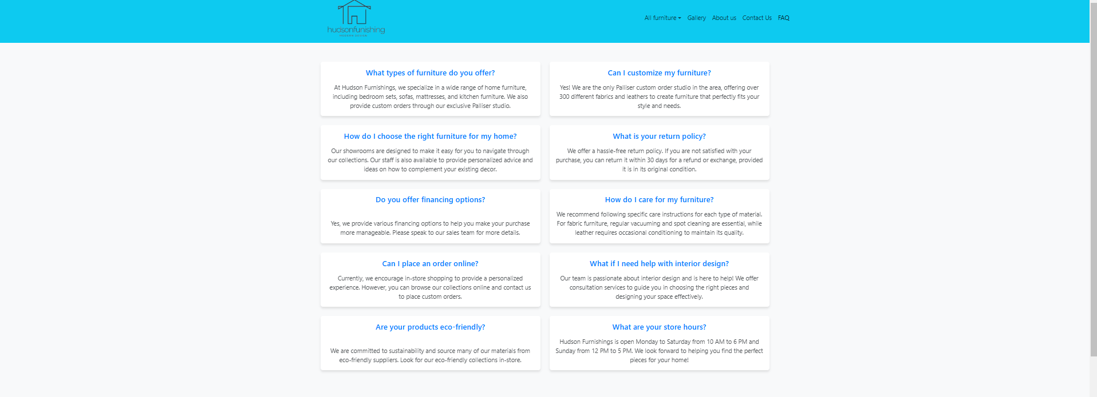

There will be many frequently asked questions that customers can read through before making a contact. In case the text is too long for answer, we can hover over the card it will be expand enough to read.A screenshot of a computer

### Gallery:

For the gallery page, we have used random math to get random 20 images in our data and display in on. There will be a zoom-in effect for each image when hover the mouse over it. The image will change randomly in a certain amount of time.A screenshot of a computer

THIS PAGE WAS LEFT BLANK INTENTIONALLY.

### About us:

Get our final destination, there is an about us page that will provide basic information about our shops with a modern design that reduces colour and eye environment.

## TASK 3 REVIEW

|  |  |  |  |  |  |  |  |
| --- | --- | --- | --- | --- | --- | --- | --- |
| **Project Ref. No.:** **eP/Furniture Store** | | **Project Title:** | **Activity**  **Plan**  **Prepared** **By:** | **Date of Preparation of Activity Plan:** | | | |
| **Sr.No.** | **Task** | **Actual**  **Start**  **Date** | **Actual**  **Days** | **Team**  **Mate**  **Names** | **Status** |
| 1 | Homepage | Hudson Finishing | Dang | 18/10/24 | 3 | Dang | Completed |
| 2 | Furniture |
| 4 | Gallery |
| 5 | FAQ |
| 6 | About Us | 19/10/24 | 1 | DANG | Completed |
| 7 | Contact |